**OUTPUT SCREENSHOTS OF LEVENSHTEIN DISTANCE ALGORITHM**

**1.WHEN INPUT IS GIVEN MANUALLY**

**1.1 BEST CASE:**

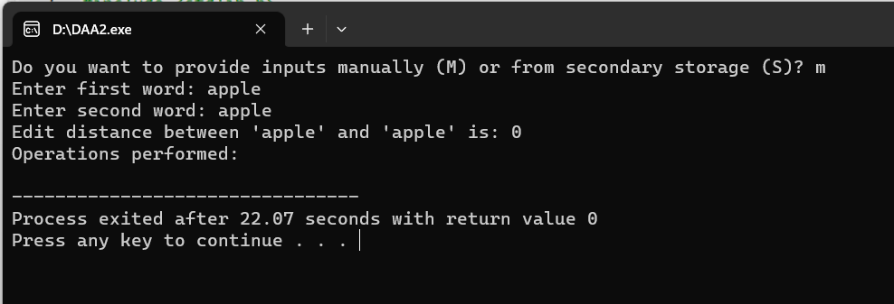

**1.2 AVERAGE CASE:**

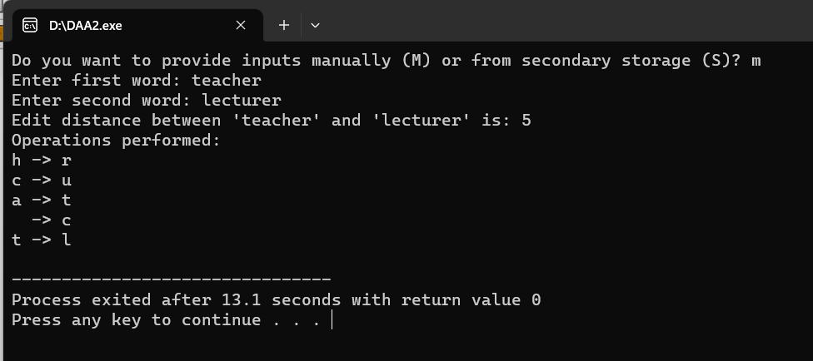

**1.3 WORST CASE:**

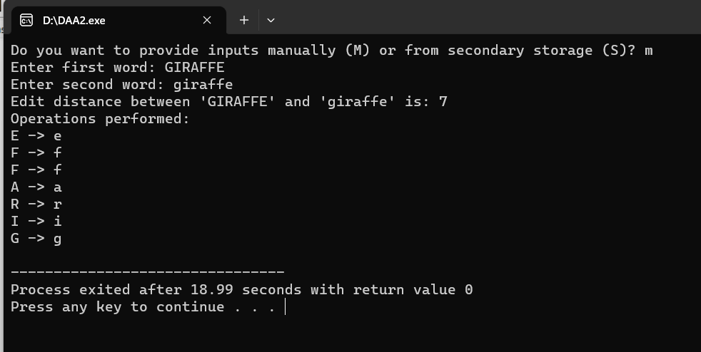

**2.WHEN INPUT IS TAKEN FROM SECONDARY STORAGE**

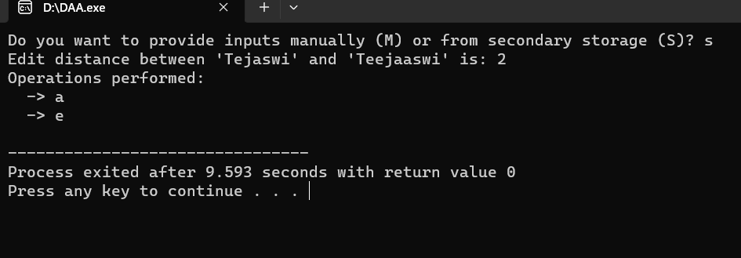

**3.WHEN YOU HAVE ENTERED A WRONG KEY TO TAKE INPUT**

